6.Create a simple cloud software application for Payroll Processing System using any Cloud Service Provider to demonstrate SaaS include the necessary fields such as Name of the employee, experience in present org , over all experience, basic pay, HRA, DA, TA, net pay, gross pay etc

Step 1:Create the form for the Initial set up

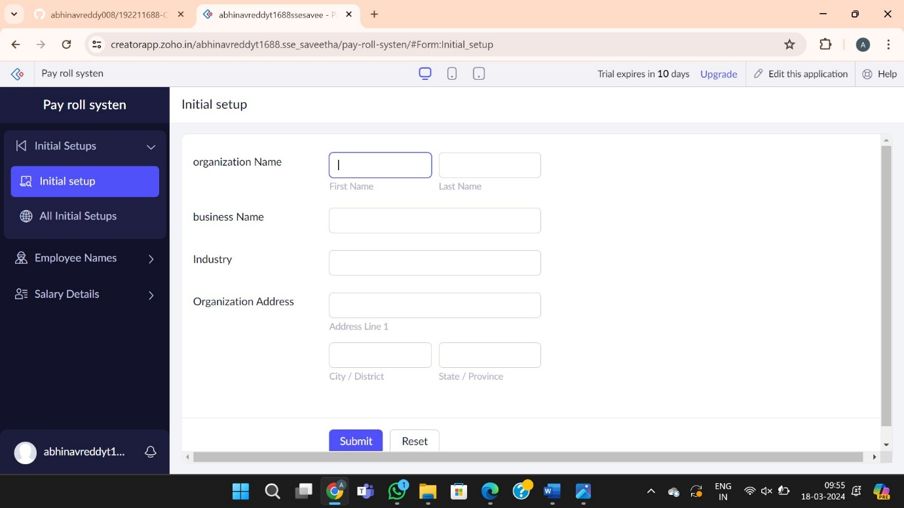

Step 2:Create the form for the employee details

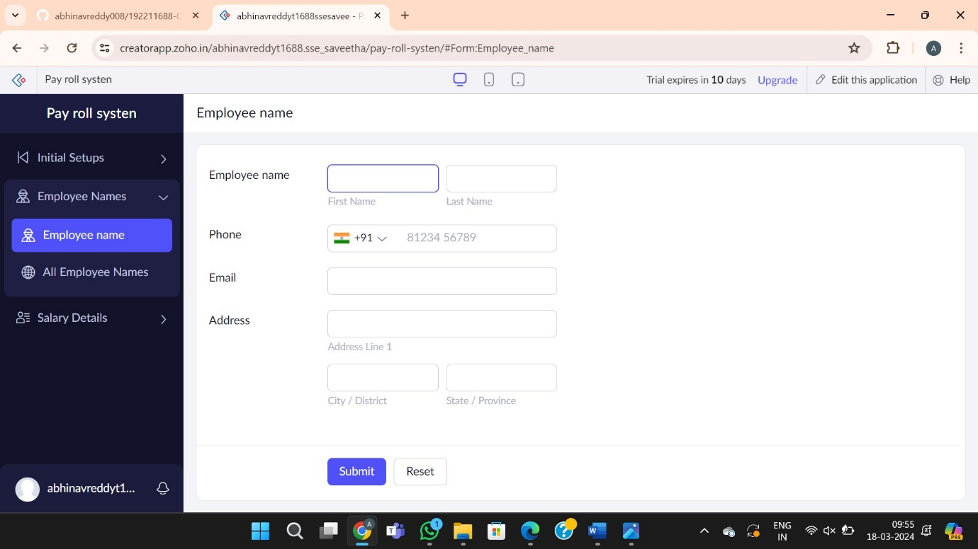

Step 3:Create the form for the Salary details

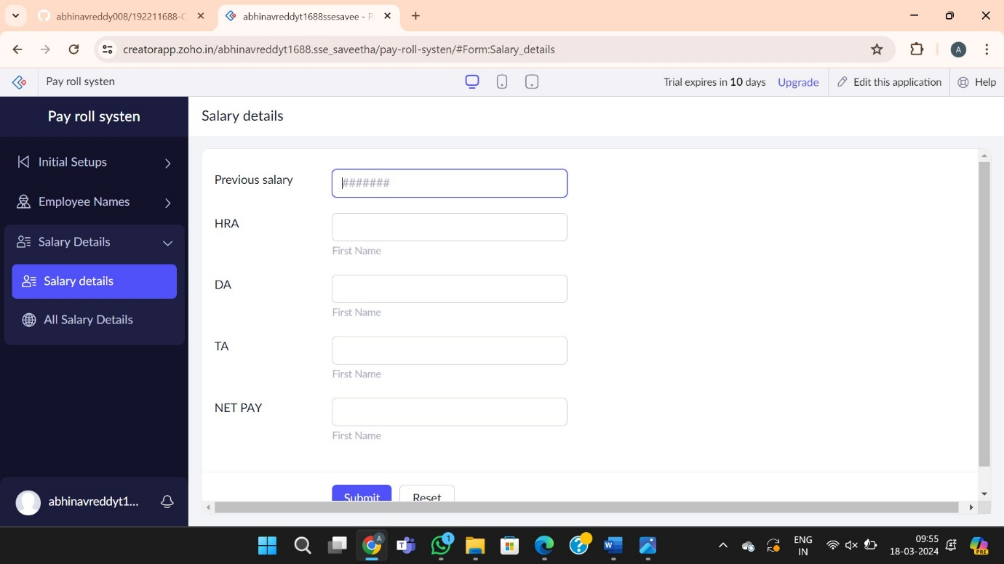

Step 4:report the forms of pay roll system

